Ch 45.1 Notes

---------------------------------------------------------------------------------------------------------------------

Vocab

---------------------------------------------------------------------------------------------------------------------

Hormones: The name for signaling molecules in the body

Endocrine System: One of the two basic systems for communication and regulation in the animal body.

Nervous System: The other major communication and control system. Is a network of specialized neurons that transmit signals along dedicated pathways.

Local Regulators: Molecules that act over short distances, reach their target cells solely by diffusion.

Paracrine Signaling: A type of signaling where target cells lie near the secreting cell.

Autocrine Signaling: A type of signaling where the secreting cells themselves are the target cells.

Prostaglandins: A group of local regulators with diverse and widespread functions.

Neurotransmitters: Molecules that diffuse a very short distance (a fraction of a cell diameter) and bind to receptors on the target cells.

Neurohormones: Diffuse from nerve cell endings into the bloodstream.

Pheromones: Chemicals that are released into the external environment so that members of a particular animal species sometimes communicate with each other.

Nitric Oxide (NO): A gas that functions in the body as both a local regulator and a neurotransmitter.

Signal Transduction: The chain of events that converts the extracellular chemical signal to a specific intracellular response.

Epinephrine: Regulates many organs, including the liver, where it binds to a G protein-coupled receptor in the plasma membrane of target cells.

Endocrine Glands: More often, endocrine cells are grouped in ductless organs called ____ such as the thyroid and parathyroid glands and the gonads, either testes in males or ovaries in females.

---------------------------------------------------------------------------------------------------------------------

Notes

---------------------------------------------------------------------------------------------------------------------

Functions of the endocrine system

Endocrine glands secrete chemical molecules

* Chemical molecules called hormones

Transmitted less rapidly compared to nervous system

* Sent to more cells and signal lasts longer

Endocrine glands and their hormones

Hormones affect functions of organs and tissues by carrying messages to specific cells called target cells

* Hormones recognize receptors on target cells
* Like a key trying to find a lock

Path of a hormone

* endocrine gland releases hormone into bloodstream
* hormone travels through bloodstream to reach target
* hormone attaches to receptor on target cell

Hormones and other signaling molecules bind to target receptors, triggering specific response pathways

Types of hormones

Water soluble

* Exocytosis travel in bloodstream
* CANNOT diffuse through membranes
* Bind to surface receptors

Lipid soluble

* Exit cell through diffusion
* Bind to transport protein to travel in blood
* Diffuse into target cells
* Receptors in cytoplasm/nucleus

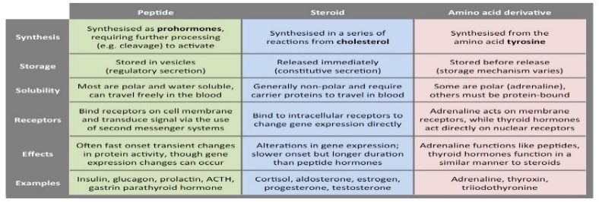

Response pathway for water-soluble hormones

Bind to cell-surface receptor

Trigger cell response

* Activate enzyme
* Uptake/secrete of enzyme/molecule
* Rearrange cytoskeleton
* Cause proteins in cytoplasm to move to nucleus and change gene expression

Response pathway for lipid-soluble hormones

Hormone diffuses in

Binds to/activates receptor that DIRECTLY triggers the cell response

Usual response= change in gene expression

Steroid receptor in cytoplasm

* Bind to hormone and complex moves to nucleus
* Alters transcription of gene

Endocrine glands

Ductless organs

Secrete hormones directly into surrounding fluid